

Tittle: | OSB Cluster 2 admin notifications (restart Admin Server)
Product: | OSB
Customer: | IMPACT
Scope Of Change: | OSB Notification AdminServer restart
Approval:

Document Control

1.1 Version History
Sl. No | Date | Author | Version | Change Reference

1.2 Reviewers
Sl. No | Reviewer | Position | Stream | Organization

1.3 Scope and Purpose of the document
This document is intended to provide a procedure to restart AdminServer (only) on “OSB 2 Notification” due to memory issue in Admin Server (JVM Heap Free percent less than 10 %).

1.4 Content
Table of Contents
1 Document Control 2
1.1 Version History 2
1.2 Reviewers 2
1.3 Scope and Purpose of the document 2
1.4 Content 3
2 System Overview 4
2.1 Introduction 4
2.2 System Impact 4
2.3 Operational Practice 4
2.4 Defeminations, Acronyms, Abbreviations 4
2.5 Assumptions, Dependencies, Constraints, Decisions 4
2.6 References 4
3 Step-by-step instructions 5
Appendix 10

System Overview

Introduction
Currently, due to high processing of messages that must be notified to BRM/OC3C GWs, from a high volume of messages received from the ECE, OC3C and BRM applications, the Admin Server has a significant memory loss causing it to crash, to avoid this a restart of the Admin Server (only) must be performed to prevent the other notification processes from continuing to operate normally.

System Impact
Operational procedures in this document can be performed at PROD environment when the Admin Server memory is below 10%, a restart of the Admin Server (only) should be performed to prevent the server from crashing, preventing other notification processes from continuing to operate normally.

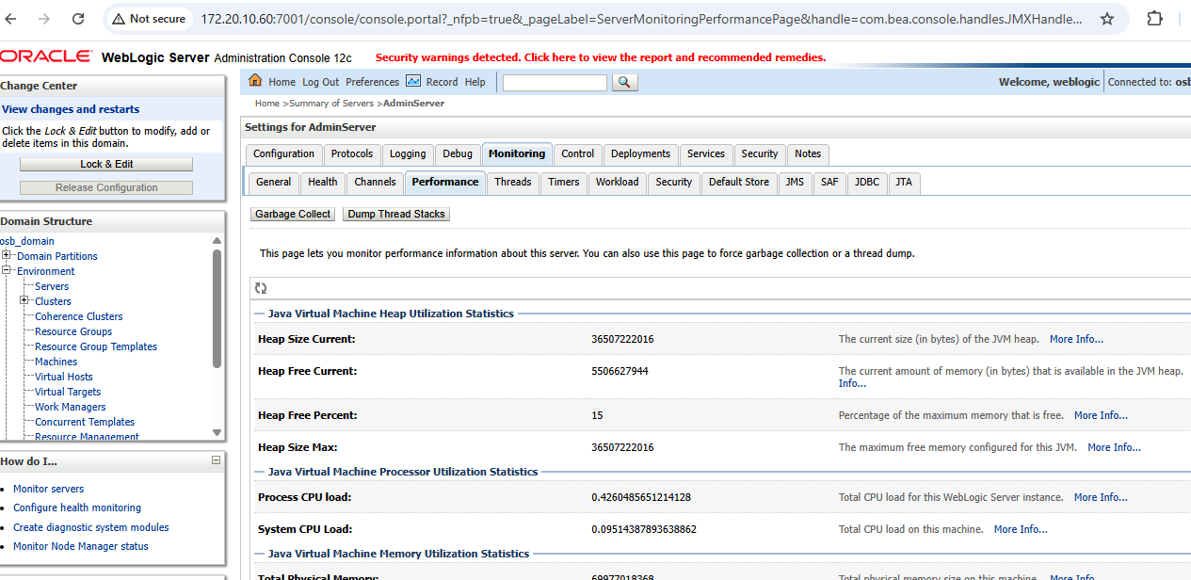

Operational Practice
It is expected that operational staff check whether, once the Admin Server is restarted, the "durable subscribers" in the JMS queues from ECE/BRM and OC3C the "Gateways" are restarted so that notifications continue to run correctly, this can be validated with the "True" status in the Admin Server JMS queues.

Defeminations, Acronyms, Abbreviations

Assumptions, Dependencies, Constraints, Decisions
Sl. No | Assumptions
1. | Admin Server memory in “OSB 2 Notification” is less than 10 % (VM HeapSize).
2.

References
Sl. No | Document Name | Document Description
1.
2.

Step-by-step instructions

It is expected that operational staff check whether, once the Admin Server is restarted, the "durable subscribers" in the JMS queues from ECE/BRM and OC3C the "Gateways" are restarted so that notifications continue to run correctly, this can be validated with the "True" status in the Admin Server JMS queues.

Login to OSB http://172.20.10.60:7001/console

ADMIN SERVER RESTART:
- Shut down “AdminServer” (only) from Production WebLogic console

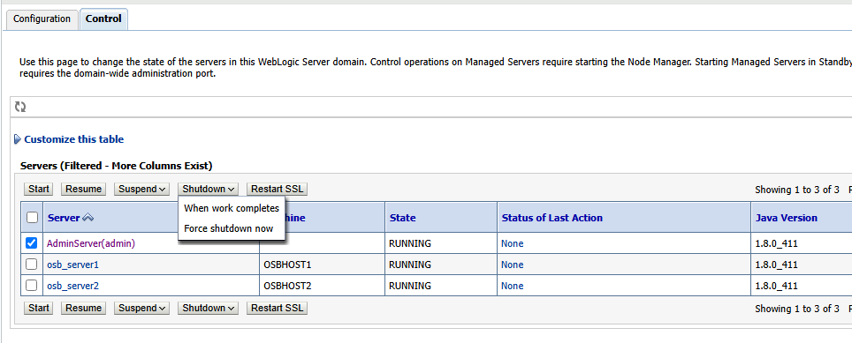

- Admin from console (172.20.2.123):
- Start Admin server:
- Go to “/app/oracle/fmw_domains/aserver/osb_domain/bin”
- Check that the “nohup.out” file has “Derby server Stopped” in its last row.
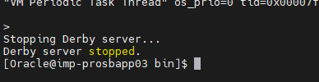

- Backup the “nohup.out” file: mv nohup.out nohup.out_ddmmyyyy
- “nohup ./startWebLogic.sh &”
- “tail -f nohup.out”
- Wait for Admin server state change to RUNNING

Note: ECE/BRM and OC3C GWs are restarted so that notifications continue to run correctly, this can be validated with the "True" status in the Admin Server JMS queues.
POST RESTART:
- Go to JMS Modules.

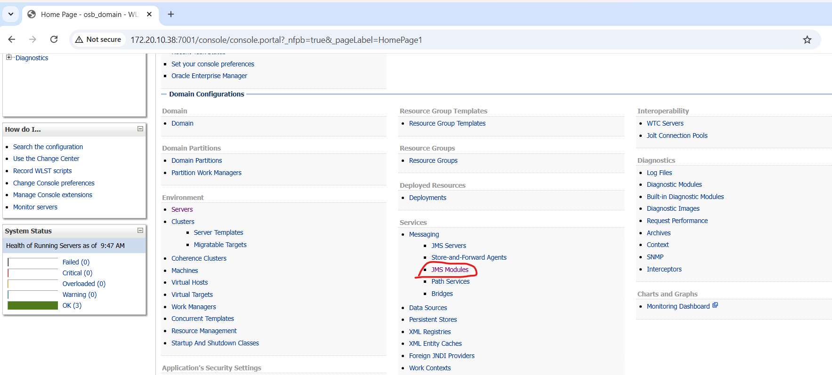

- Check for JMS Subscribers should be in 'true' from WebLogic console:
Home ServicesMessagingJMS Modules Summary of JMS Modules
- Modules:
  - ECE: NotificationTopicMonitoringDurable Subscribers:
NotificationTopic - BRM gateway, OC3C NGW and ECE

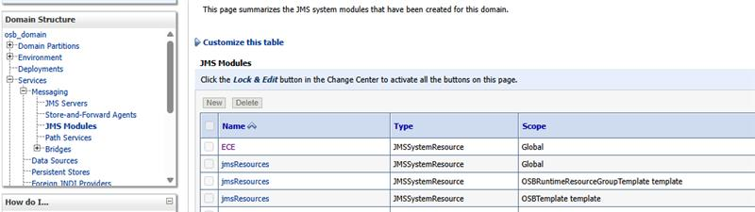

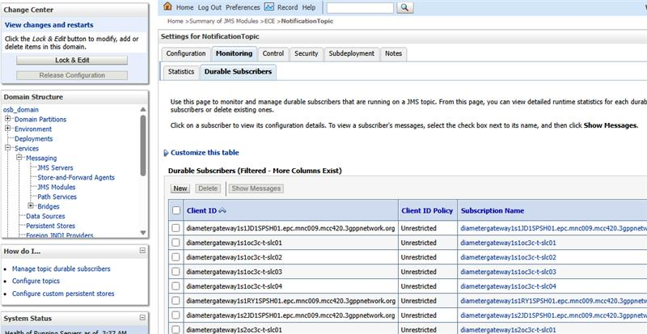

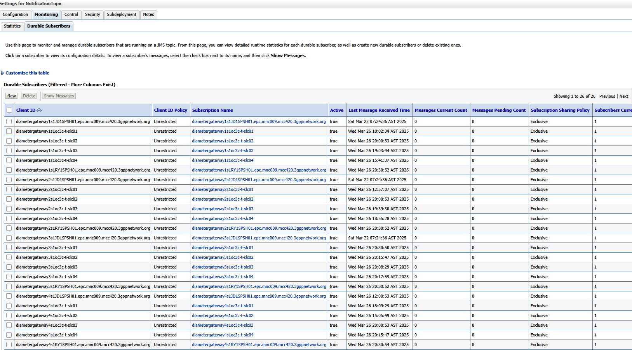

Appendix
Ongoing Work
Sl. No. | Activity | Work Description | Owner

Common problems
Sl. No. | Defect/Bug ID | Identification Phase | Issue Resolution

Known Issues
Sl. No. | Defect/Bug ID | Identification Phase | Issue Resolution

